**Basic Linux commands**

**File Editors:**

1. cat

cat > file1 (Create a new file “file1” and put content inside the file) - create & Write

cat >> file1 (Append the content to existing file) - Append

cat file1 (To show/read the content in the file) - Read only

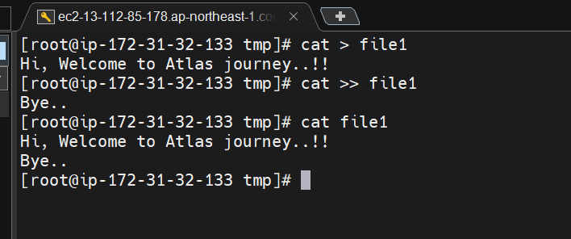

1. touch
   1. to create a new empty file – create only

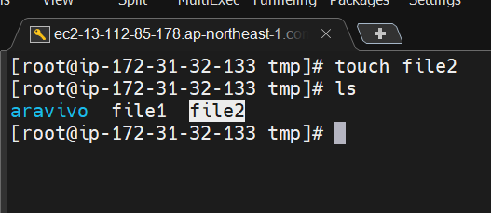

1. vi
   1. create ( or ) open and edit the file
   2. To enter the content, press ‘i’
   3. To exit the file and save – esc & :wq!

**Flags:**

w - save the file

q – quit the file

! – force quit

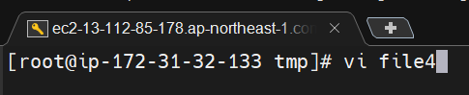

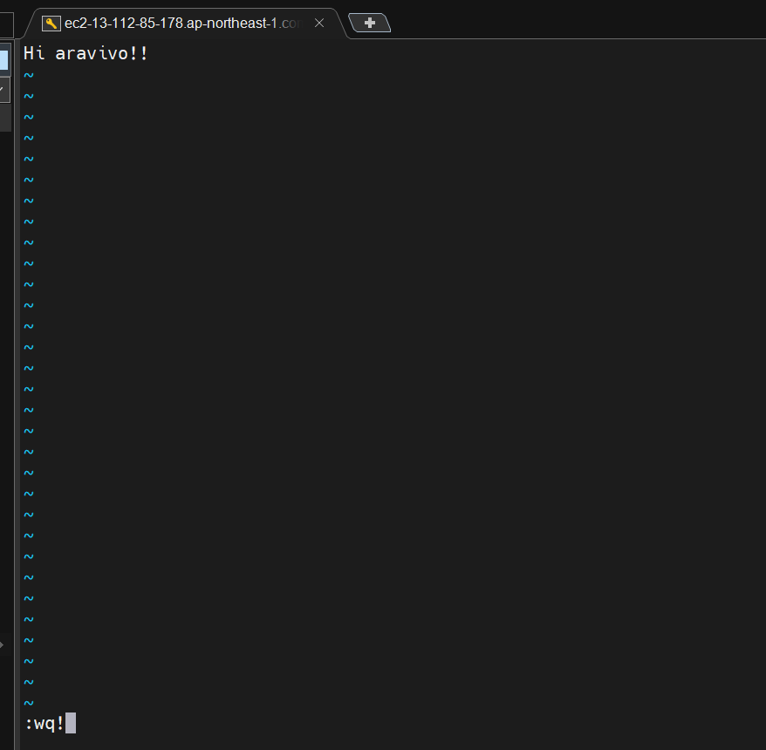

1. Nano
   1. Create and edit the file
   2. Ctrl+X to exit and Y to save the file.

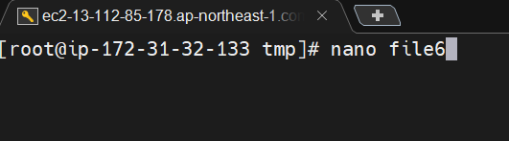

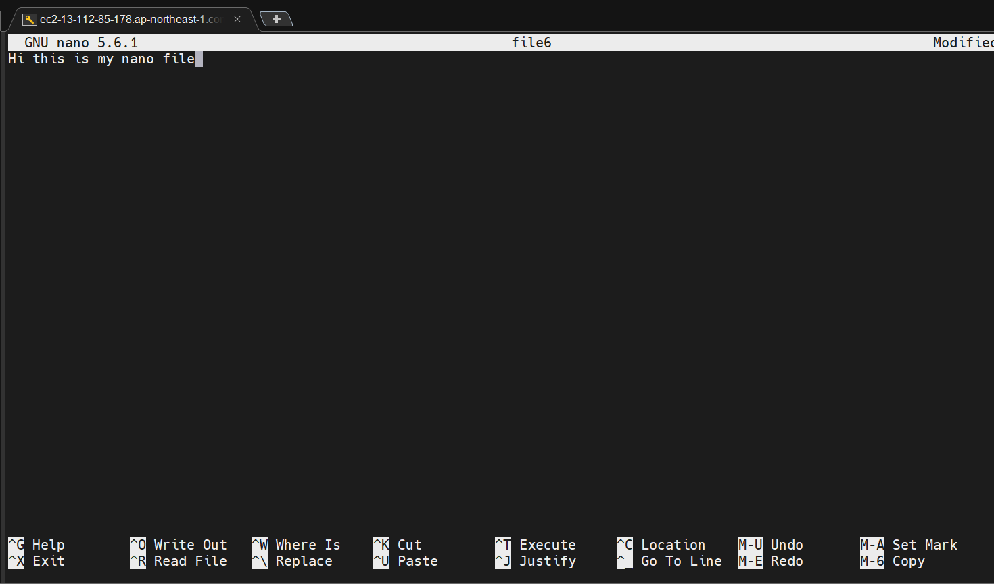

**Directory commands:**

1. pwd – Print working directory

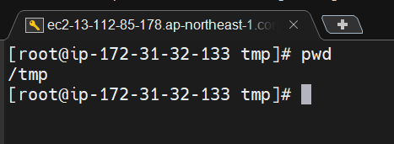

1. tree
   1. Tree is a package to show the list of directories/files in a tree structure.
   2. Install package: **$ yum install tree -y**
   3. Run command: **$ tree**

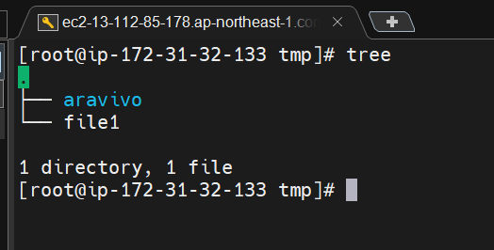

1. ls
   1. list all the folder and files in current working directory (or) in a path. **Command: $ ls**
   2. To show the hidden files and folders. **Command: $ls -a**
   3. To show the long list of the all the files. **Command: $ls -al**
   4. To see the subdirectories and files. **Command: $ls -R**

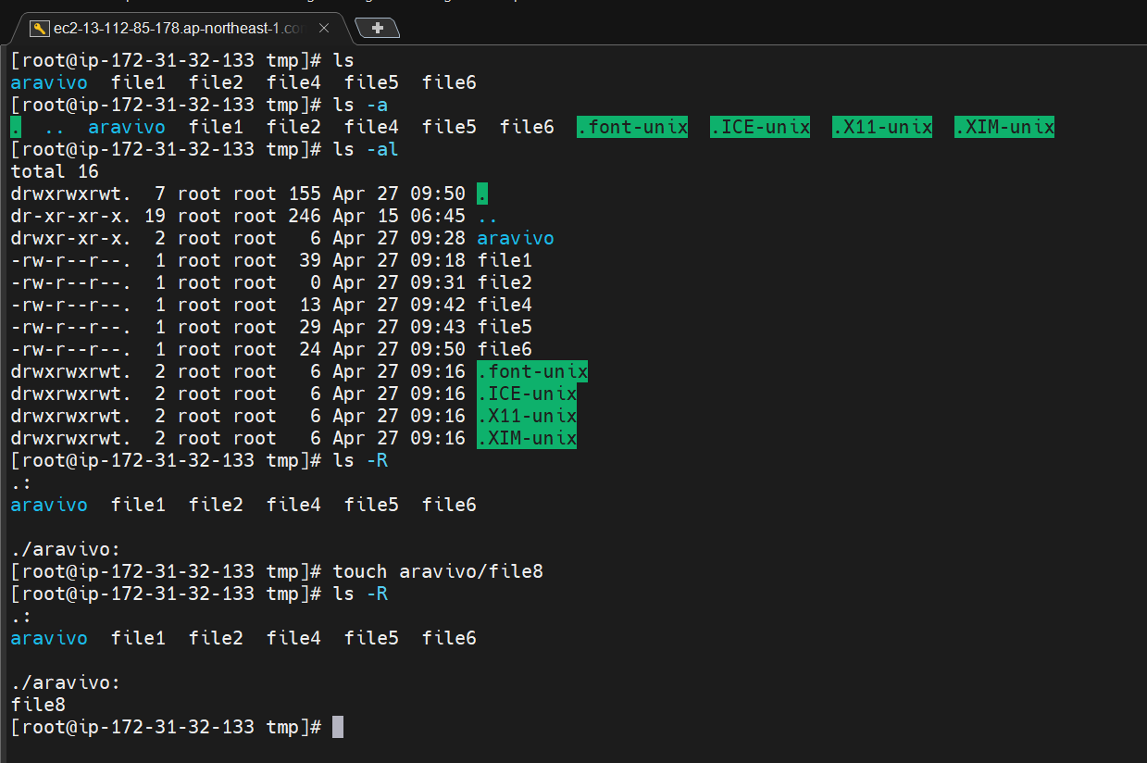

1. mkdir
   1. to create a empty directory. **Command: $mkdir <folder_name>**
   2. To create a folder inside a another folder **Command : $mkdir -p dir1/dir2/dir3**

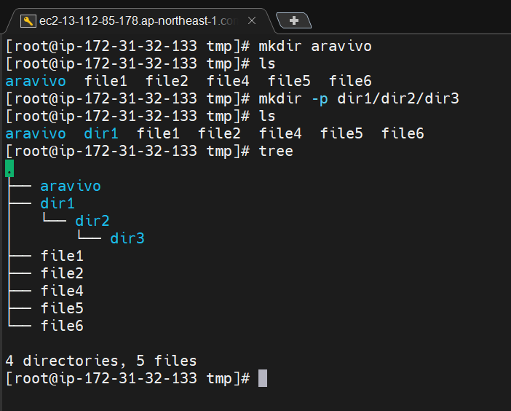

1. Remove directory or file

**Command : rm -rf <folder or file name>**

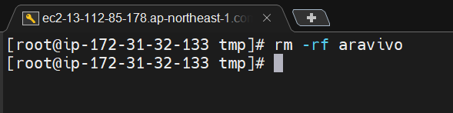

1. Copy file / directory

Command: cp <sourcefile> <desination>

